Name ______________________ Group # ________

Series RLC Homework
5V @ 4.711kHz
R_{int}
R₁
L₁
C₁
R_{W}
L₁ = | 80mH
R_{w} = | 121Ω
C₁ = | .01uf
R_{int} = | 100Ω
R₁ = | 700Ω

X_{L} | _____________
Q_{Coil} | _____________
X_{C} | _____________
R_{T} | _____________
X_{tot} | _____________
Z_{T} | _____________
θ | _____________
I_{T} | _____________
E_{L1} | _____________
E_{C1} | _____________
E_{R1} | _____________
P_{R1} | _____________
True Power | _____________
Apparent Power | _____________
Reactive Power | _____________
Power Factor | _____________

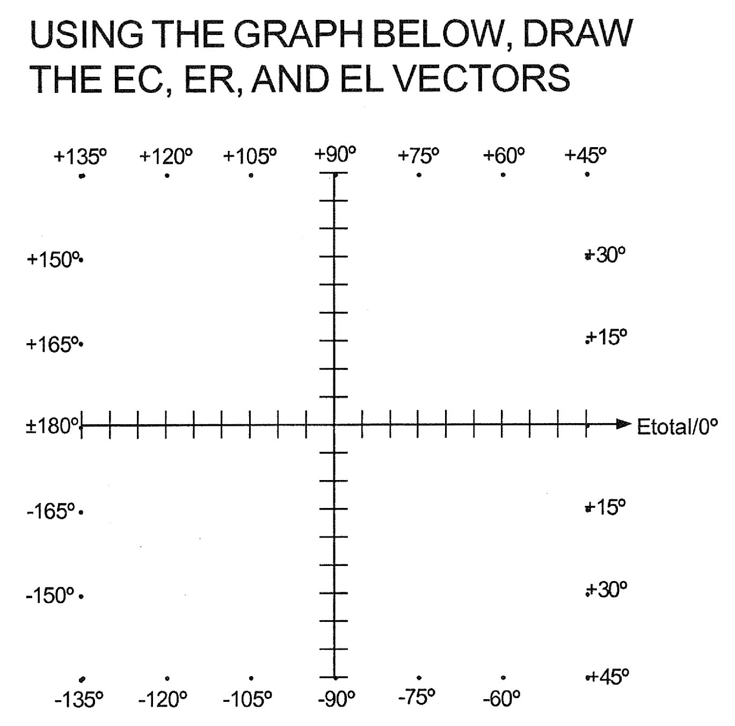

5V @ 6.543kHz
R_{int}
R₁
L₁
C₁
R_{W}
L₁ = | 80mH
R_{w} = | 121Ω
C₁ = | .01uf
R_{int} = | 100Ω
R₁ = | 700Ω

X_{L} | _____________
Q_{Coil} | _____________
X_{C} | _____________
R_{T} | _____________
X_{tot} | _____________
Z_{T} | _____________
θ | _____________
I_{T} | _____________
E_{L1} | _____________
E_{C1} | _____________
E_{R1} | _____________
P_{R1} | _____________
True Power | _____________
Apparent Power | _____________
Reactive Power | _____________
Power Factor | _____________

5V @ F_{r}
R_{int}
R₁
L₁
C₁
R_{W}
L₁ = | 80mH
R_{w} = | 121Ω
C₁ = | .01uf
R_{int} = | 100Ω
R₁ = | 700Ω

F_{r} | _____________
X_{L} | _____________
Q_{Coil} | _____________
X_{C} | _____________
R_{T} | _____________
X_{tot} | _____________
Z_{T} | _____________
θ | _____________
I_{T} | _____________
E_{L1} | _____________
E_{C1} | _____________
E_{R1} | _____________
P_{R1} | _____________
True Power | _____________
Apparent Power | _____________
Reactive Power | _____________
Power Factor | _____________

